<PROJECT NAME (PROJECT NUMBER)>  <VERSION NUMBER OF THIS DOCUMENT> | SYSTEM ARCHITECTURE

Table of Contents
1 Executive Summary 4
1.1 Purpose and History 4
1.2 Project Objectives 4
1.3 Intended Audience 4
1.4 Assumptions 4
1.5 Contributors 4
2 Architectural Overview 5
2.1 Architecture Scope 5
2.2 Business Process Model (BPM) Overview 5
2.3 Architectural Drivers (i.e. Interoperability, Extensibility, Availability, etc.) 5
2.4 Integration Type 5
2.5 Impacted Architectural Domains 5
3 Logical Architecture 6
3.1 Conceptual Models 6
3.2 Logical Models 6
3.3 Technology Inventory 6
3.4 Architectural Dependencies 6
4 Hardware Architecture 7
4.1 Tiers 7
4.2 Client Hardware Models 7
4.3 Server Hardware Models 7
4.4 Mass Storage Devices 7
4.5 Peripheral Equipment Models 7
4.6 Additional Models 7
5 Network Architecture 8
5.1 Overview 8
5.2 Technology 8
5.3 Traffic Flow 8
6 Security Methodologies and Requirements 9
6.1 Security Overview 9
6.2 Identity Management Methods & Models 9
6.2.1 User Authentication 9
6.2.2 System Authentication 9
6.2.3 Authorization 10
6.2.4 Provisioning 10
6.3 Information Security 11
6.4 Application Logging 12
6.5 Remote Access Requirements 12
7 Communications Architecture 13
7.1 Communications Model 13
7.2 Interface API’s 13
7.3 Message Management & Queuing 13
7.4 Interfaces 13
8 Data Architecture 14
8.1 Data Architecture Model 14
8.2 Relational Databases 14
8.3 File Stores 14
8.4 Transaction Management 14
8.5 Content Management Architecture Model 14
8.6 Business Intelligence 14
9 User Interface Architecture 15
9.1 User Interface Summary 15
9.2 Navigation 15
9.3 User Interface Architecture 15
10 Operational Management Architecture 16
10.1 Production Support 16
10.1.1 System Management 16
10.1.2 System Monitoring 16
10.2 Patch Management 16
10.3 Deployment 16
10.4 Startup and Application Recovery 16
10.5 High Availability 16
10.6 Disaster Recovery 16
10.7 Mechanisms for Quality Requirements 16
11 Performance Architecture 17
11.1 Load Balance Model 17
11.2 Pooling Techniques 17
11.3 Hardware & Software Distribution and Management Plan 17
11.4 Architecture Scaling Model (Scale-Up or Scale-Out) 17
11.5 Load Testing Mechanisms 17
12 Vendor Related Information 18
12.1 Vendor Overview 18
12.2 Proprietary Communication 18
12.3 Proprietary Database Formats 18
13 Development Architecture 19
13.1 Language Stack 19
13.2 Design Patterns 19
13.3 Tools Used 19
13.4 Third Party or Open Source Libs 19
13.5 Versioning Strategy 19
13.6 Source Code Management and Packaging 19
14 Approvals 20
15 Appendix 21
15.1 Architecture Decisions 21
15.2 Requirements Trace 21
15.3 Major Unresolved Issues 21
15.4 TBD’s 21

Revision History
Version | Date | Author(s) | Summary of Changes
V 1.0 | 7/18/2017 | Ravi Patel | Initial Creation.
V 1.1 | 7/19/2017 | Ravi Patel | Section 10 added information from IaC.
V 1.2 | 10/18/2017 | Arun Kumar. S | Architecture Review
V 1.3 | 10/24/2017 | Ravi Patel | Made changes based on the provided feedback.
V 1.4 | 10/26/217 | Ravi Patel / Arun Kumar S. | Reviewed and finalized changes.
V 1.5 | 11/6/2017 | Ravi Patel | Made changes based on feedback from Security.
V1.6 | 11/7/2017 | Arun Kumar. S | Architecture Review
V 1.7 | 11/8/2017 | Ravi Patel | Added AWS WAN Network Details under Section 5
V 1.8 | 11/8/2017 | Arun Kumar. S / James Cupps | Architecture Review in hand with Security Architecture Review

Document Tailoring Guidelines
This document may be tailored to fit the needs of the project team. Sections may be added that are used in specific functional areas, however, the sections contained in this document should not be removed. If a section contained herein is not applicable to the project mark it as “Not applicable” in the section.

Executive Summary

Purpose and History
As part of Phase 1 of the Hybrid Cloud Program, the Amazon Web Services (AWS) Virtual Private Cloud (VPC) Innovation Lab Implementation Project will put in place an internal facing (Tier 3) Innovation Lab leveraging the AWS hosting platform to expand scalability and flexibility over the current Innovation Lab.

This project will support hosting upcoming prototypes and Proof of Concepts (PoCs) by implementing Virtual Private Clouds (VPC), Virtual Private Network (VPN), Active Directory (AD) connector, and Domain Name Service (DNS) forwarders in the new AWS account. Predefined templates will be published to consume AWS services. After implementation of the AWS VPC Innovation Lab, the PoC Council will govern the upcoming prototypes and PoCs.

Once implemented, the AWS Innovation Lab will:
- Be available for 5/3 IT teams to perform prototypes and PoCs
- Include access to 5/3 data center and non-prod data environments
- Not provide direct access to/from public internet to the newly created VPC

Project Objectives
- Expand scalability and flexibility over the current Innovation Lab
- Increase capacity for PoC and prototype demand on Innovation Lab
- Provide Application Development Teams the ability to test new functionality leveraging AWS
- Enable access to 5/3 Non Production Environment

Intended Audience
- Enterprise Architecture
- Security Architecture
- Audit
- IT Risk
- IT Shared Services

Assumptions
- Participating teams have the resources to meet the required deliverable dates
- Security requirements will be addressed as part of this project and signed off by security, business controls, and IS risk teams
- Required Vendor Management and Sourcing Processes will be completed in a timely manner

Contributors
The following individuals contributed to the content of this document:
Name | Type | Phone | E-mail
Venkatesan Ramanathan | Author |  | Venkatesan.Ramanathan@53.com
Ravi Patel | Author | 513.358.0297 | Ravikumar.patel@53.com
Arun Kumar. S | Reviewer | 513.358.5521 | ArunKumar.S@53.com
Garcia Pinal, Ramon | Reviewer | 5135348671 | Ramon.GarciaPinal@53.com
Thorner, Christopher | Reviewer | 5133587857 | Christopher.Thorner@53.com
Cupps, James | Reviewer | 5135346867 | James.Cupps@53.com

Architectural Overview

Architecture Scope
- Expand scalability and flexibility over the current Innovation Lab
- Increase capacity for PoC and prototype demand on Innovation Lab
- Provide Application Development Teams the ability to test new functionality leveraging AWS
- Enable access to 5/3 Non Production Environment

Business Process Model (BPM) Overview
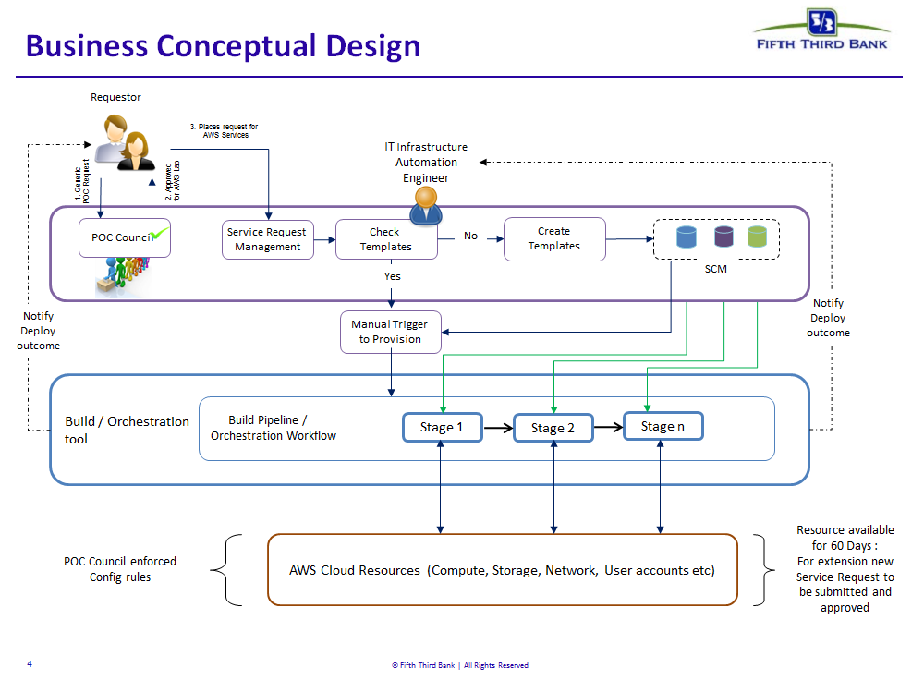

Architectural Drivers (i.e. Interoperability, Extensibility, Availability, etc.)
- Innovation
- Flexibility
- Scalability

Integration Type

  - Portal Authentication
    - SAML federation using RSA FIM will be used to authenticate users to AWS console.
  - Domain Joining for Windows VMs
    - Windows VMs will be coming back through the VPN tunnel and will communicate with the existing on-prem AD to join a domain.
  - Access to AWS Apps/Services
    - SAML federation using the RSA FIM solution will be used to authenticate users to the AWS console.
    - Roles will be created in AWS for access to different applications and services.
    - Users will then be associated with an appropriate role which will provide the user access to specific applications and services.
  - Infoblox DNS appliance will be provisioned in AWS.
  - Qualys appliance will be deployed in AWS to perform vulnerability scans on the resources deployed in AWS.
  - This solution will integrate with Qradar.

Impacted Architectural Domains
- Innovation Lab, Identity Federation, VPN, Cloud Security Framework

Logical Architecture
This section should include descriptions of how conceptual software pieces and interfaces will work together to achieve the goals of the architecture. Please do not articulate hardware architecture in this section. This section should be written from the perspective of the administrators of the conceptual pieces and interfaces.

Conceptual Models

Logical Models
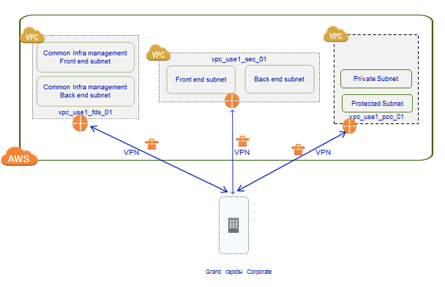
Figure 1 - AWS WAN Network model

Technology Inventory
ID | Technology Component | Platform | Application Layer | Description
 | AWS | Cloud Service | Layer 3 | Host Off Prem Innovation Lab
 | Infoblox DNS | Network | Layer 3 | DNS Integrated with 5/3

Architectural Dependencies
- SAML Identity Federation, Qualys, Qradar
- Infoblox DNS - Corporate WAN and AWS VPCs for DNS Grid access
- Internet proxy settings to allow access to RHUI for server patching.
- VPN as well as other TCP/IP and Network Setup

Hardware Architecture
This section should include details and specifics around existing hardware layouts in all environments of architecture. This section should include details around any hardware solutions for HA or failover goals. This section should also include details around location and life cycle on the hardware in all environments.

Tiers
N/A

Client Hardware Models
- Browser based and Command line based access through SSH.

Server Hardware Models
- Only specific T-shirt sizes for VMs will be offered in AWS.
"AWS_T2_SM (1CPUx2GB RAM)"

"AWS_T2_MD (2CPUx4GB RAM)"

"AWS_T2_LG (2CPUx8GB RAM)"

"AWS_T2_XL (4CPUx16GB RAM)"

"AWS_T2_2XL (8CPUx32GB RAM)"

"AWS_M4_4XL (16CPUx64GB RAM)"

Mass Storage Devices
N/A

Peripheral Equipment Models
N/A

Additional Models
N/A

Network Architecture

Overview
General Connectivity to Amazon Web Services (AWS)
- Within US East 1 Region, each of the 3 VPCs would be setup with VPN gateway for connecting to on-premises through VPN
- The VPN connection will be used for routing traffic in and out of AWS to/from On-Premises
- 802.1q identifiers are required for VLAN tagging and for VPC mapping
- IPSEC VPN tunnel will be used to interconnect AWS VPCs to on-premises through internet
- For remote users, access to AWS private (VPC) resources will be provided via the existing remote access infrastructure, via the VPN connectivity to AWS
- VPN will be the primary means of connectivity of AWS, till such time MPLS is implemented
AWS – WAN Network Details
- Each of the 3 VPCs has a direct VPN connection to on premise.
- Each VPN tunnels are configured with Static Routes. These static routes provide the necessary information to AWS to route non-AWS-VPC traffic back to on premise.
- These are the static routes that are currently configured for all of the VPN tunnels to AWS:
10.224.0.0/16 | Dev Servers Subnet in GRAMI  Terraform, Packer, Inspec, etc..
10.220.184.0/23 | MOB subnet Cloud Engineering team (Ethernet)
10.212.217.49/32 | Prod Site Scope Server
10.212.186.36/32 | Non-Prod Site Scope Server
0.0.0.0/0 | The Default route for all other traffic.
- NOTE: The 0.0.0.0/0 static route is necessary on the VPN alongside the 0.0.0.0/0 route in the route table. AWS will not route non-AWS-VPC traffic to on premise if the route is only in the route table.
AWS – LAN Network Model - Details
- 3 VPCs will be created upfront
- 1 VPC for common management / shared cloud resources
- 1 VPC containing security services and tools
- 1 VPC for all PoCs
- Foundational services / Common management VPC
    - Contains cloud services / resources that provide common management functionality to resources in other VPC (for e.g, AD, DNS, Antivirus etc.)
    - Contains 2 type of subnets
    - Front end subnet – For deploying common management cloud resources that require access to internet - Upfront there isn’t any need for this subnet but IP space will be reserved for future consumption
    - Back end subnet – For deploying common management cloud resources that do not require access to internet
    - Access is restricted to Infrastructure management team
- Security services VPC
    - Contains cloud resources specific to security services and tools
    - Access is restricted to Information security team
    - Contains 2 subnets
    - Front end subnet for hosting security tools - Upfront there isn’t any need for this subnet but IP space will be reserved for future consumption
    - Back end subnet for hosting Logs & associated storage
  - PoC VPC
    - Contains the Proof of Concept resources approved by the PoC council
    - Access is restricted to the owner of the PoC
    - Subnets will be created on demand as necessary to separate multiple PoCs.
    - By default the VMs will be provisioned in a private subnet (no internet gateway). If internet access is required, appropriate security group and NACL changes will need to be made to allow traffic to be routed back to on-premise network through the VPN tunnel. Once on-premise, traffic will use existing channels to access the internet.
AWS -- LAN IP Addressing of the Subnets and VPCs
- The IP Addresses for all of the VPCs were provided to us by the network team.
  - Foundation VPC is assigned the range 10.18.0.0/20
  - Security VPC is assigned the range 10.18.16.0/20
  - PoC VPC is assigned the range 10.22.64.0/19
Subnet Type | Foundation VPC 10.18.0.0/20 |  |  | Spare Subnets
Availability Zones | us-east-1a | us-east-1b | us-east-1c | us-east-1d
Private | 10.18.8.0/27  10.18.8.32/27  10.18.8.64/26  10.18.8.128/25  10.18.9.0/24 | 10.18.10.0/23 | 10.18.12.0/23 | 10.18.14.0/23
Public | 10.18.0.0/23 | 10.18.2.0/23 | 10.18.4.0/23 | 10.18.6.0/23
 | Security VPC 10.18.16.0/20
Availability Zones | us-east-1a | us-east-1b | us-east-1c | us-east-1d
Private | 10.18.24.0/23 | 10.18.26.0/23 | 10.18.28.0/23 | 10.18.30.0/23
Public | 10.18.16.0/23 | 10.18.18.0/23 | 10.18.20.0/23 | 10.18.22.0/23
- The IP addresses for each of the subnets within each of the VPCs were divided and assigned by the Cloud Engineering team.
  - For the Foundation VPC, decision was made to split the one big range into 8 individual subnets.
    - One of those 8 individual subnets (10.18.8.0/23) was broken up further into 2 subnets of /24.
    - One of the two /24 subnets (10.18.8.0/24) was broken up further into 4 individual subnets as seen in the table. The decision to break the subnet down to a /27 was derived from on-premise architecture of the Infoblox servers. All Infoblox servers on-prem are deployed in a /27 subnet and the decision was to match this in AWS. Infoblox appliance also had a requirement for 2 network interfaces in two different subnets; we achieved this by assigning one network interface from the 10.18.8.0/27 subnet and the other from the 10.18.9.0-24 subnet.
  - For the Security VPCs, decision was made to split the one big range into 8 individual subnets. See below.

  - Allocated ranges for 3 Private subnets and 3 Public subnets in each of the VPCs referred in the table above. Also allocated ranges for the 2 spare subnets in each of the VPCs, 1 Private and 1 Public.
  - All 3 private subnets were created initially for both Foundation and Security VPCs. The 1 spare for each VPCs were documented for future use.
  - Architecture Decision is to create all subnets of the same type in different AZ’s within each VPC’s to ensure HA and redundancy

Technology
- AWS
  - Virtual Private Network (VPN) – Connectivity between 5/3 and AWS
  - Virtual Private Cloud (VPC) – Foundational Services, Security Services, and POC VPCs
  - Firewall – Deployed On-Premise to filter traffic to and from AWS.
  - Infoblox (DNS) from AWS Marketplace.
  - Windows Active Directory

Traffic Flow – Current Firewall Rules

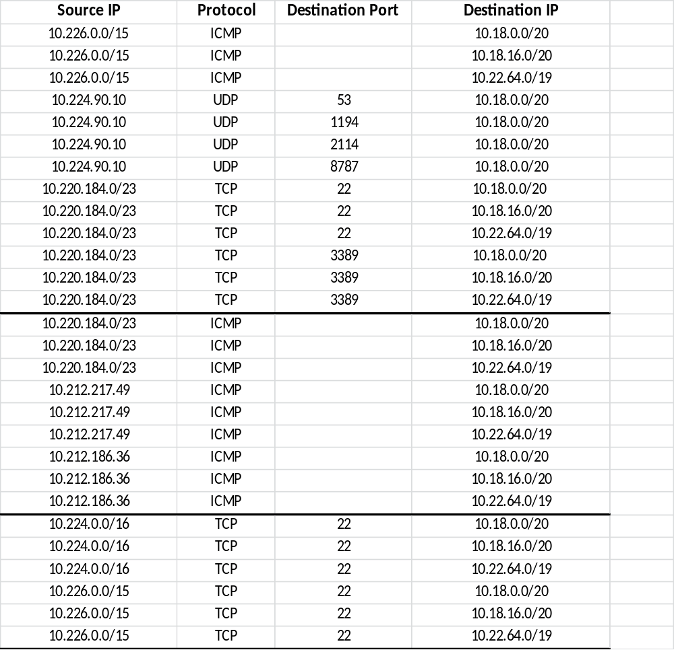

Security Methodologies and Requirements

Information Security best practices, standards, regulations and industry requirements will be used in the assessment of new or modified systems to reduce security-related vulnerabilities and exposures.

Security Overview

In addition to the information required in this section, a network diagram with ports, protocols (HTTP, ODBC, SMB, etc.) and network tiers (Tier-1 Internet Application, Tier-2 Internet Application, Restricted Zone, Shared Services Zone, Tier-3.) explicitly noted must be provided.

Identity Management Methods & Models

User Authentication

Name | Users | AWS Role | ED Entitlement
Ravi Patel | E974192 | Administrator | To be updated when Entitlements are created in the PROD Enterprise Directory
Arun Kumar S | E971212 | Administrator
Jason Leupen | E709183 | ReadOnly
Venkatesan Ramanathan | T99055A | PowerUser
Deepak Kumar Bhoopalan | T12920A | PowerUser
Daniel Solomon | T10664A | PowerUser
Anupama Udgata | T17243A | PowerUser
Murali Kumar | T62974A | PowerUser
Ankit Chaturvedi | T15044A | PowerUser
Keerti Kothari | T15632A | ReadOnly
Shweta Atulkar | T15296A | ReadOnly
Umesh Mane | T15299A | ReadOnly
Amir Kazemi | E973939 | ReadOnly
Tony Mi | E975674 | ReadOnly
Jim Cupps | E976337 | ReadOnly
Production Federation URL: https://employee.53.com/AWS
Non-Prod Federation URL: https://np.employee.53.com/AWS - Only to be used until the Production ED integration is complete.
- The above users have been added to the Enterprise Directory and have been associated with their corresponding roles.
- The authorization of the users is controlled by the “b53AWSrole”.
- AWS IAM will be used for administration of Functional accounts. These accounts are strictly CLI.
    - Functional accounts require keys to authenticate to AWS APIs. Since there is currently no solution at the bank that allows for federated access for CLI accounts, the decision is to use AWS IAM until such time there is a solution that allows for this functionality.
- Windows VM AD authentication will happen via the VPN to our existing on-premise AD services.

- AWS KMS (Key Management Service)
  - Fkms account has been created and given access only to the KMS service. This account will be used to access KMS and pull an encryption key.
  - This encryption key is used to encrypt a file locally on the terraform server which contains credentials for the fterraform IAM account. This file is decrypted at runtime of a script to reveal to the credentials and use the fterraform IAM account for infrastructure provisioning in AWS.
  - At the end of the script, the decrypted file is deleted and only the encrypted file is kept.

AWS S3 access
  - List of users who can access S3 with their assigned roles.

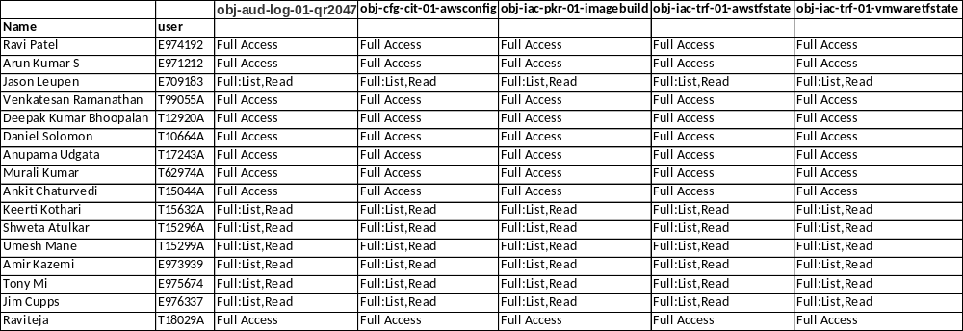

  - Active Directory Integration

Authentication Entry Point  (Intranet, Internet, Mainframe, Internal Network, other) | Authentication  Mechanism
Internal Network
Explain “Other” Authentication Mechanism. | Details:

If two-factor or multi-factor authentication is used, describe the additional authentication methods used.
For example: tokens, smart cards

System Authentication
System to system and backend data source validation.

Describe authentication methods between applications and backend data sources (2-way SSL, functional ids…) | Details:  The authentication mechanism for the VMs is Active Directory and Enterprise Directory.

Authorization
Defines the access rights/privileges that have been granted to a user.
Authorization Mechanism
Authorization will be handled through mapping of AWS roles to myAccess entitlement groups that provide fine grained access to AWS resources for federated user identities.
Explain “Other” Authorization Mechanism
Details:
Can user administration functions be segregated from other application functions, including other application administration functions? | Specify Yes or No:
Can user access rights/privileges be extracted or reported on to verify user access? | Specify Yes or No:
Is privileged access required to run or administer the application?  Examples:  - Local Administrator  - Root | Specify Yes or No:

Provisioning
Refers to the creation, maintenance and deactivation of user ids and attributes, as they exist in one or more systems, directories or applications through an automated or interactive business process.

If access rights are managed by the internally by the application, describe available mechanisms for automating user access administration. Indicate if an API or batch interface is available. | Details:
 | Rights are managed by AWS IAM roles and are mapped to myAccess entitlement groups.
If users IDs are stored internally, can application support IDs prefixed with special characters (i.e. #)? | Specify Yes or No:
 | If no, describe how existing # IDs will be accommodated.
If access rights are managed internally, are these privileges granted through templates, which are copied to users, or roles, which propagate access rights to users. | Details:

Additional Comments:

Information Security
Based on the information classification, different levels of protection are required.

Indicate the information classification that has been determined for the information types (e.g., customer information, user passwords, company confidential) stored, processed or transmitted by this application.

Information  Types | Information  Classification
POCs
Foundation Services VPC
Security Services VPC
Describe the transaction type(s) | Monetary | Non-Monetary | N/A
Is encryption used to protect any restricted data? | Specify Yes or No:
Is Cardholder data transmitted, logged or stored?  Examples:  - Card Number  - PIN  - Card Holder Name  - Expiration Date  - Track 2 credit/debit card data (i.e., card authorization data) | Specify Yes or No:
 | If yes, list all cardholder data elements.
Is encryption used to protect passwords and authenticators both at rest and in transit? | Specify Yes or No:
Are passwords logged? | Specify Yes or No:
Is all Internet traffic encrypted? | Specify Yes or No:
Describe any additional encryption the system utilizes. | Details:

Additional Comments: This is an infrastructure enablement project and not an application that will house data. We will utilize best pratices for AWS to deploy and manage infrastructure. We will use best practices recommended by AWS to deploy and manage infrastructure.

Application Logging
Application system logs are created by an application to keep a historical record of events such as transactions processed, users added and deleted, security violations and other information.

Does the application log administration activity? | Specify Yes or No:
Does the application log security violations? | Specify Yes or No:
Does the application log user activities? | Specify Yes or No:
Describe where logs are stored: application database or file, OS file, etc. | Details:
 | AWS CloudTrail Service
Describe the reporting features the application provides for printing, retrieving and reviewing application logs. | Details:
 | CloudTrail logs can be accessed by via management console and API.

Additional Comments:
AWS Cloud Trail service will be used for fulfilling logging requirements for AWS innovation lab workloads.
AWS VPC flow logs will be enabled for logging networking traffic within AWS
AWS cloud trail and VPC flow logs will be enabled for consumption by Qradar service
The object ID of the S3 bucket where the CloudTrail logs are kept is: obj-aud-log-01-qr2047.
The flogging functional account has been provided with the access to this bucket.
The flogging functional account is used by Qradar for consuming logs stored in this S3 bucket.
Per the discussion with Brandon Brown, Christopher Fant and Garcia Pinal Ramon on 08/29/2017, it’s been decided to
- Write the cloudtrail logs to an S3 bucket for consumption by Qradar
- Access to S3 bucket containing logs is to be restricted to only the Source IP of Qradar.
- VPC flow logs to be enabled for all VPCs in AWS
- The logs will be filtered and tested in non-prod Qradar (for the AWS innovation lab)
- Logs will be sent to the On-premises Qradar. Qradar collector option (within AWS) to be explored by the Infosec team
VPC Flow logs will be streamed to AWS Firehose, from AWS Firehose the logs will be delivered to a S3 bucket for consumption by Qradar.

Remote Access Requirements

Is there a requirement that the application be accessible remotely? | Specify Yes or No:
Is temporary vendor support required? | Specify Yes or No:
Is ongoing vendor support required? | Specify Yes or No:

Additional Comments:

Communications Architecture
This section should include how system interfaces are going to communicate. This section usually includes the details of integrating two (or more) systems. Interface descriptions and any agreed upon communication methodologies should be articulated here. Some examples are: SOAP, RMI, and FTP.

Communications Model

Interface API’s
- AWS APIs used to provision infrastructure.
- Service Catalog API will be used to pull information about requests which then is used to provision infrastructure.

Message Management & Queuing
N/A

Interfaces
N/A

N/AData Architecture
This section should include details around database layouts, designs, and decisions. Please be sure to include data going to and from the documented system. If a custom database is being designed, please articulate Entity Relationships, Indices, Constraints, Triggers, etc. to help the reader fully understand specific database details around this platform. This view should be written from the perspective of a junior DBA on this platform.

Data Architecture Model
The data type to be used on this environment and the ownership of data is determined by the POC council. Please refer to the EULA and PoC council process document for further information.

Relational Databases
N/A

File Stores

N/ATransaction Management
N/A

Content Management Architecture Model
N/A

Business Intelligence
N/A

User Interface Architecture
This section should be used to describe any user interface tools and design patterns that were used. Any navigation needs and solutions should be referenced here.

NOTE: By users, we mean POC counsel approved LOB Developers and Managers.

User Interface Summary
- Users will request access through Remedy.
- Users will consume services through a web browser or SSH command line.
- Administrator users will administer using the API.

Navigation
- Users will access AWS as if they were accessing any other resource on our network. This will be facilitated by a VPN between AWS and 5/3.

User Interface Architecture

Operational Management Architecture
This section is critical for all architectures. All the support models and SLA needs should be articulated here. The procedures for maintaining the environment should be written here. Where specific groups will get involved to help support this architecture for it user base is very important here. It is not uncommon to see references to the Command Center, Administrators and the Help Desk.

Production Support

System Management

System Monitoring
- All resources in the Foundation Services and Security VPCs will be monitored as necessary.
- Currently Infoblox DNS server which resides in the Foundation VPC is being monitored.
- The Qualys scanner in the Security VPC did not need to be monitored as per the Vulnerability Management team.

Patch Management
- Existing Patch management setup of Fifth third bank for windows servers (SCCM) will be used for fulfilling patch management requirements for Windows VMs deployed in AWS innovation lab
- RedHat Update Infrastructure will be accessed via on-premise proxy server to patch RHEL VMs deployed in AWS.
  - The Firewall has been configured with rules to allow the resources in all VPCs (All VPC Ranges) access to RedHat Update Infrastructure (RHUI) on the internet.
  - The Proxy has been configured to allow unauthenticated access from resources in all VPCs (All VPC Ranges). The access is limited to ONLY RedHat Update Infrastructure (RHUI) URLs hosted on AWS by RedHat. – Https://aws.ce.redhat.com
- Scope of patch management will be limited to the foundation services and security services VPC resources
- Patch management will be offered for the Linux workloads deployed on-demand in application POC VPCs, on need basis.

Deployment
Leverage Tata Consulting Services (TCS) high and low level design documents created during the Cloud Design Project to:
- Establish Infrastructure Build (Packer), Infrastructure Deploy (Terraform), Infrastructure Testing (InSpec) agreements and accounts
- Leverage Source Code Management, and Application Release Automation Tool enterprise agreements and accounts
- Install and configure tools provided in #1. If tools provided in #2 are not available at the bank, install and configure equivalent open source version of the identified product for consumption and migrate the artifacts to the enterprise implemented versions as part of separate effort at a later date
- Build operating system images and develop automation tasks
- Build test cases and develop automated test functions to test the images
- Build the service provisioning and develop automation tasks
- Build and develop workflows to orchestrate the image build and service provisioning process
- Develop and integrate the orchestration capability with Service Request Management function as applicable
- Identify Support Process to support the new tools and process mentioned above
- Create runbooks and other documentation for support of IaC
Provide training to support personnel and users

Startup and Application Recovery
- N/A

High Availability
- N/A

Disaster Recovery
- AWS native snapshot capability will be used for fulfilling any backup requirement for AWS innovation lab workloads. This capability will not be available unless specifically requested.
- Snapshot management tools are not required at this point
- Only Crash consistent backups will be taken for the EC2 instances.
- Application consistent backups (filesystem level backups) will not be made available at this point

Mechanisms for Quality Requirements
- AWS Trusted Advisor
  - Trusted Advisor provides real time guidance to help provision resources following AWS best practices.
- AWS Config Service will be used to audit Infrastructure configuration changes.
- IaC Peer Review
  - Peer reviewing the code as well as the deployed infrastructure.

Performance Architecture
Performance plans and designs should be detailed in this section. Typically links to performance test results, future plans, and SLAs can also be linked here. Performance goals can also be articulated here.
Many times architectural decisions are modified based on the performance needs, so architectural decision docs can also be linked in here.

Load Balance Model
N/A

Pooling Techniques
N/A

Hardware & Software Distribution and Management Plan
N/A

Architecture Scaling Model (Scale-Up or Scale-Out)
N/A

Load Testing Mechanisms

N/A

Vendor Related Information
The section is marked to handle any pertinent information about the vendors used in this solution. Any unique technical scenarios about a vendor’s solution can also be articulated here.

Vendor Overview
- For the efforts in this project, we will be on-boarding a vendor, AWS (Amazon Web Services). Amazon Web Services is a Public Cloud provider that will be hosting 5/3 innovation lab workloads for POCs and prototyping.

Proprietary Communication
- Please refer to the Communication Model above in 7.1 for a detailed host communications diagram.

Proprietary Database Formats
N/A

Development Architecture
This section should only be used when developing or customizing applications. Use this section to articulate all development decisions and design paradigms that are relevant to the architecture. This section should be written from the point of view of a junior developer on this platform.

Language Stack
N/A

Design Patterns
N/A

Tools Used
N/A

Third Party or Open Source Libs
N/A

Versioning Strategy
N/A

Source Code Management and Packaging
N/A

Approvals
For the minimum required signatories for this document, see Approval Matrix for PLC projects on PMO Intranet site. Additional key stakeholders may be added to ensure that all affected functional areas have been addressed.
By approving this document, the approver agrees that the content contained herein is accurate and complete; agrees to abide by the change management process identified for changes to this document; and is providing approval based on his/her role in this project (for Sign-off definition for artifact-role combination, see PMO Intranet site).

Approvals are stored with all project artifacts at: <insert path to folder where approvals are stored>.

Appendix

Architecture Decisions

Requirements Trace

Major Unresolved Issues

TBD’s

